**10 SCIENCE 2014**

### CHEMISTRY TEST ONE

Name: ____________________ Teacher: ___________________ Mark: /60

**Percentage %**

**SECTION A: MULTIPLE CHOICE (10 marks)**

**Please answer on the multiple choice answer grid.**

|  |  |
| --- | --- |
| **Number of question** | **Answer** |
| **1** | **A B C D** |
| **2** | **A B C D** |
| **3** | **A B C D** |
| **4** | **A B C D** |
| **5** | **A B C D** |
| **6** | **A B C D** |
| **7** | **A B C D** |
| **8** | **A B C D** |
| **9** | **A B C D** |
| **10** | **A B C D** |

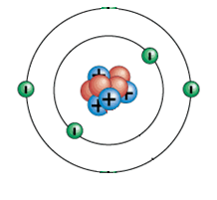**1.** The atom on the right has a:

(a) Neutral charge.

(b) Positive charge.

(c) Negative charge.

(d) Nucleus charge.

**2.** Ions are particles with:

(a) A positive charge or negative charge.

(b) No charge

(c) The same number of protons a elections.

(d) The same number of electron shells as protons

**3.** The atomic symbol for a gold atom is . Clarify what this tells you about the gold atom.

1. It contains 118 protons.
2. It contains a total of 197 protons, neutrons and electrons.
3. It contains 118 neutrons.
4. It contains 197 electrons.

**4.** The periodic table was first put together in 1869 by the Russian chemist

(a) Ernest Rutherford.

(b) John Newlands.

(c) Dmitri Mendeleev.

(d) Antoine Lavoisier.

**5.** A pure substance made up only one type of atom is called a/an:

(a) Ions

(b) Compounds

(c) Minerals

(d) Elements

**6.** Choose the correct definition for matter ‘.

(a) Anything that has a charge

(b) Anything that takes up space and has mass

(c) Anything that can be seen with the naked eye.

(d) Any solid or gas.

**7.** Choose the correct definition for atom‘.

(a) Simple particles that form the building blocks of all matter.

(b) A charged particle

(c) The particles making up solids

(d) Two or more elements chemically joined together.

**8.** Which of the following are all ***transition metals***?

(a) Li, Mn, Ca

(b) Mn, Fe, Cu

(c) F, Cl, Br

(d) Na, K, Fe

**9.** the noble gasses are all:’.

(a) found on the right hand side of the periodic table and highly reactive.

(b) found on the left hand side of the periodic table and highly reactive.

(c) found on the right hand of the periodic table and unreactive.

(d) found on the left hand of the periodic table and unreactive.

**10.** When the periodic table was first sit up it had:

(a) 90 elements

(b) 104 elements

(c) fewer elements than are known today

(d) more elements than are accepted as pure elements today.

**SECTION B: SHORT ANSWER ( 60 marks)**

**1.** Fill in the table below. (5 marks)

|  |  |
| --- | --- |
| **Element** | **Symbol** |
| Helium |  |
|  | Be |
| Carbon |  |
|  | P |
|  | K |
| Calcium |  |
|  | Li |
|  | B |
| Silicon |  |
|  | S |

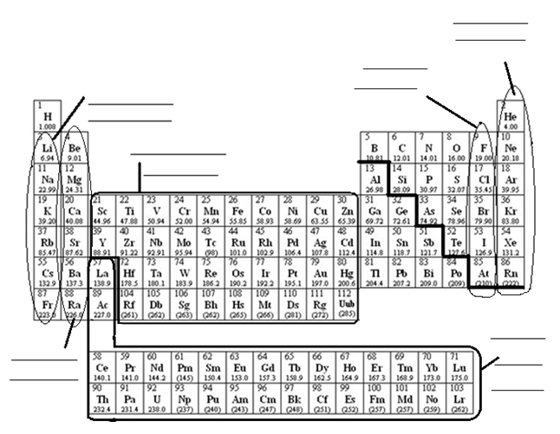**2.** a. Fill in the diagram of the periodic table below. (6 marks)

b. Use the results for question 2.a complete the table below.

|  |  |
| --- | --- |
| Element | Group of the periodic table |
| Lithium |  |
| Helium |  |
| Chlorine |  |
| Iron |  |
| Magnesium |  |
| Nitrogen |  |
| Sodium |  |

( 8 marks)

**3.** Complete the electron configurations below (neatly in pencil). (6 marks)

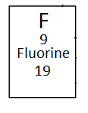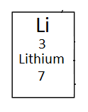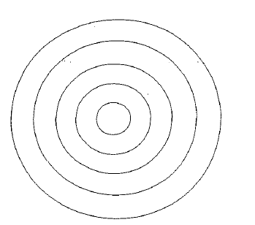

**4.** Label the diagram of the atom below. (2.5 marks)

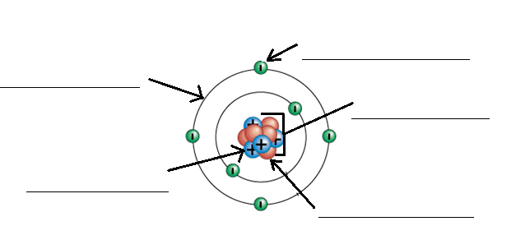

5. Use the periodic table supplied at the back of this test booklet to complete the table below.

|  |  |  |  |  |  |
| --- | --- | --- | --- | --- | --- |
| Element | Atomic number | Mass number | Number of protons in each atom o the element | Number of neutrons in each atom of the element | Number of electrons in atom of the element. |
| Carbon |  |  |  |  |  |
| Silver |  |  |  |  |  |
| Helium |  |  |  |  |  |
| Magnesium |  |  |  |  |  |

(10 marks)

6. Draw a graph using the information from the table below. (5 marks)

|  |  |
| --- | --- |
| **Generator type** | **Efficiency (%)** |
| Hydro electric | 95 |
| Tidal power | 90 |
| Wind turbine | 40 |
| Coal | 48 |
| Solar photovoltaic | 25 |

[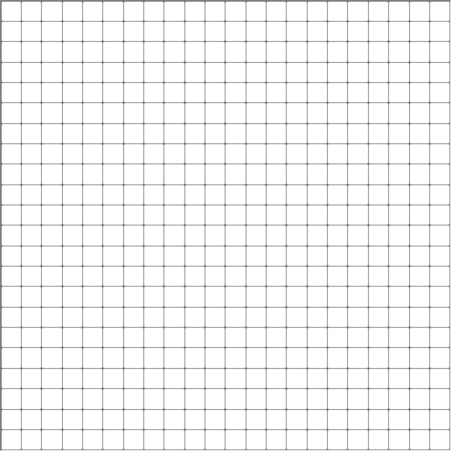](http://www.google.com.au/url?sa=i&rct=j&q=graph+paper&source=images&cd=&cad=rja&uact=8&docid=bnDyK-WDEHhooM&tbnid=OH_xw5ZTcFEuvM:&ved=0CAUQjRw&url=http://virtualmathtutor.blogspot.com/2010/11/how-to-draw-circle-without-compass.html&ei=RKw4U5fxF8fClQWCrIGoCQ&psig=AFQjCNHahbsWAgdANQM5RZCXw4z48cLLBw&ust=1396309252654415)